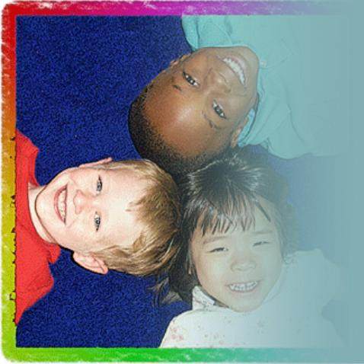
Impact Child Outcomes
Using Data to Inform Practice and Measure Outcomes: Six State Examples
Arkansas
What they are doing: Using court data on all the children/youth in dependency-neglect cases in grades K-12, and analyzing their ability to provide educational continuity for these youth.
How it will effect outcomes for youth: The educational continuity data and the implications it has on education and permanency outcomes will be presented to stakeholders statewide, bringing attention to the issue. Reports will also be developed by judicial districts and counties with the intent that Judicial Leadership Teams including the bench, bar, child welfare and education stakeholders will identify issues and make recommendations for improvement plans for their judicial districts and counties to improve outcomes for children/youth.
How they are measuring success: The Commission recently formed a committee on outcome measures and accountability.
Who the partners are: Education, Court, Child welfare agency
Data sharing: Arkansas has successfully implemented an interagency data exchange where court and agency data match. They are now working on getting the education system involved.
How they use data in creative ways: Send data to judges on performance outcomes (timelines and permanency) and how they rank with other judges to encourage some conversation and competition. Currently working on dashboards for judges to have performance outcomes available on their computers to help them manage their individual cases.

Colorado
What they are doing: Conducting "Permanency Site Visits" in three counties/jurisdictions to discuss what "permanent home" meant in the state. Permanency and timeliness reports were used to drive the discussions, as were assessments of each jurisdiction's data measurements. Colorado also has Best Practice court Teams and Practice Model Teams (child welfare) in each jurisdiction that work to create systems change.
How it will effect outcomes for youth: Using the data gathered from the Permanency Site Visits as well as a statewide convening of Best Practice Court Teams and Practice Model Teams, the state plans on setting realizable permanency goals.
How they are measuring success: systemized site visits to all jurisdiction where multi disciplinary stakeholders observe court and report on the quality of hearings.
Who the partners are: Court, Child welfare agency.
Data sharing: Our state has a real time data exchange between the D&N courts and child welfare. The court side has several reports that measure such things as timeliness and permanency. Working with Education to distinguish youth in foster care in their reports.
How they use data in creative ways: Judicially led statewide case flow workshops for child welfare stakeholders to talk about the case from a data driven perspective.
Kentucky
What they are doing: Created a report that judges can easily run that simply lists the cases that have been open the longest.
How it will effect outcomes for youth: The report will inform judges and they can concentrate on those cases that have been open the longest.
How they are measuring success: They hope to compare the average length of time that children remain in care among cases and determine whether judges who pay special attention to those outliers at the far end will have a greater reduction of time overall for these children as compared to judges who do not use the report. Kentucky has also designed a new court observation form that is related to the Toolkit indicators of quality. Findings from this are shared with the judge who uses it with his or her team to improve practice.
Who the partners are: Court, Child welfare agency.
Data sharing: Current data system does not have capacity to add new indicators that would be helpful. CW shares permanency data and CPS call/substantiation data and schools share aggregate data, but courts would like better flow of data.
How they use data in creative ways: Created "Local Site Snapshots" that have colorful sections for CPS call/substantiation data, Permanency Data, Census date, court data, school data, and selected well being measures taken from Kids Count for the county. These are shared with judges in each county and CIP partners.

New Mexico
What they are doing: Measuring the timeliness of various court hearings
How has it affected outcomes for youth: Hearings have become more timely. They have also raised awareness among all parties and stakeholders about the importance of timeliness. The outcome measures have been built into our new court data system (Odyssey) so that more detailed data can be extracted than historically has been.
Who the partners are: Court, Child welfare agency, attorneys, advocates. Current efforts to include education in collaborative work.
Data sharing: Routinely share aggregate data and report both court and agency data in the same publications. Not yet at the point of data sharing on a case-by-case basis. Currently installing a new Odyssey system at the court that will include all Toolkit measures.
How they use data in creative ways: Promoted Child Welfare Improvement Plans in every Judicial District in New Mexico by using our outcome data and holding facilitated meetings in each District. Each District developed short term action plans with specific steps, timeframes, and responsible parties to address those outcomes that were of highest priority to them.

Ohio
What they are doing: Implemented the Ohio Summits on Children in 2008 and 2009 to open communication and expand partnerships at both the state and local levels, which coincided with CIP supported activities and initiatives.
How it will effect outcomes for youth: The summit resulted in new and expanded partnerships to help maximize their internal and external resources. Collaborations resulted in the development of a local share vision for the safety, well-being, and permanent living situations for children.
How they are measuring success: They measured case timeliness data as well as how counties were managing their motions for permanent custody caseloads and compared those counties who participated in the Summits with those that did not.
Who the partners are: Court, Child welfare agency.
Data sharing: Each county maintains their own independent court data systems, so it is difficult to gather data at the state level. Aggregate child welfare data is shared on the Summit for Children website. The courts are currently working with the education system to identify opportunities for data sharing.
How they use data in creative ways: Publish data charts for each of the Summits on Children that showed both statewide and county specific data. There is a webpage for additional data: summitonchildren.ohio.gov/data/default.asp.

Washington
What they are doing: Created an internal "Interactive Dependency Timeliness Reporting System" to address the need for frequent and robust data feedback and reporting to the field. The interactive reports can be customized to view different elements of state and individual county data for broad comparisons or person/case-specific information. They can be used to summarize, analyze, explore and present the case data, as well as drill down into the case level raw data for auditing, look-ups, case documentation verification, and clean up.
How it will effect outcomes for youth: Putting the data "back in the users hands" will help the courts assess their outcomes and be able to improve service delivery in a data-informed way.
How they are measuring success: Working with the child welfare agency on a "Process to Outcomes" project that will focus on how processes relate to outcomes.
Who the partners are: Court, Child welfare agency, the Attorney General's office, and the OPD staff, as well as with the University of Washington.
Data sharing: The court and child welfare data systems are separate and do not communicate. However, a full time position was created to work on the data exchange process between the courts and the child welfare agency. Reports of court data are shared with the child welfare agency.

